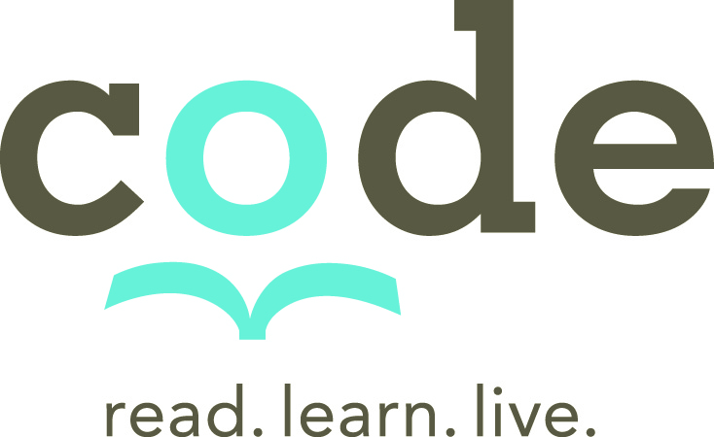
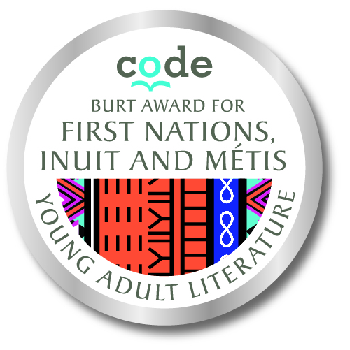

Terms of Reference

Education resource guide development specialist for
CODE’s First Nations Inuit Metis Young Adult Literature Program

CODE is seeking an education consultant with experience in First Nations, Inuit, and Metis context to develop a teacher guide template and six reading/classroom/teacher resource guides for six of the First Nations Inuit Metis Young Adult Literature awarded books.

Work to be completed in two stages: Stage 1: April 30, 2020, Stage 2: September 2020.

Candidates should submit a proposal highlighting their relevant experience, proposed process, expected daily rate in Canadian dollars, the total number of hours/days estimated to complete the work and a CV to https://codecan.applicantstack.com/x/apply/a2h8bz7rl3hl?preview=1 by January 24, 2020 (applications will be reviewed on a rolling basis).

- Background Information
CODE is a Canadian charitable organization that supports literacy and learning around the world. For 60 years, CODE has worked in partnership with local organizations to expand literacy in Africa, the Caribbean, and Canada by providing children and youth with access to quality reading materials, supporting the professional development of teachers and librarians, and helping to strengthen the local book trade and national publishing capacities.
The CODE Burt Award for First Nations, Inuit and Métis Literature
In 2012, building on our experience, and in recognition of our responsibility as a Canadian organization, CODE established the Burt Award for First Nations, Inuit, and Métis Young Adult Literature along with the Assembly of First Nations, Inuit Tapiriit Kanatami, the Métis National Council, the National Association of Friendship Centres, Frontier College, GoodMinds, the Association of Canadian Publishers, and the Canada Council for the Arts. These organizations help us to determine where to put our energy and resources so we can improve Indigenous youth’s access to engaging and culturally meaningful books; to ensure that Indigenous writers and publishers know about the award and can submit their work; and to keep the program relevant reflective of the realities of today’s Indigenous youth. We also work with the Canadian Teachers’ Federation’s Advisory Committee on Indigenous Education to inform the resources created to support teachers, librarians and educators.
The CODE Burt Award for First Nations, Inuit, and Métis Young Adult Literature is a Canadian literary award and readership initiative that recognizes excellence in Indigenous-authored literature for young adults (ages 12-18). The objective of the prize is to champion literacy, build language skills and foster the love and habit of reading by ensuring that young people across Canada have access to high quality, culturally-relevant and engaging reading materials.
The award is a cash prize given annually to three literary works for young adults written by First Nations, Inuit, and Métis authors in English and an Indigenous language. Publishers of the winning titles are also awarded a guaranteed purchase of up to 2,500 copies of each title. These books are then distributed to schools, libraries, community centres, and Friendships Centres across Canada. This guaranteed purchase, combined with a book distribution program, is what makes this award program unique. It ensures that great books make it into the hands of young readers who need them the most, with new titles coming out every year!
- Scope of Work:
In line with the above-mentioned objectives, CODE is seeking an education specialist with experience in developing teacher resource guides for the period of 10 February, 2020 to 31 September 2020.

CODE and the consultant will agree prior, in writing, to the number of days expected for each specific output and based on the agreement the consultant will invoice accordingly. The expected products of this consultancy are:

- A teacher resource guide / classroom guide template that can be shared and used by publishers, authors, consultants, teachers, librarians to create content for any Burt Award YA Literature book.
The template would need to incorporate active-learning methodologies with a strong focus on inquiry-based learning. The template will also need to incorporate the perspectives set out in the Guiding Principles for the Development of Lesson Plans to Support Indigenous Youth Literature - developed by the Canadian Teachers’ Federation’s (CTF/FCE) advisory committee on Indigenous education. The template should include outline for 5 or 6 sections for example:
  - Active Learning and Inquiry-based process of novel/literature study, setting up a reading club etc., how to create a link/joint school study with an indigenous school or community (sharing experiences and parallel study activities).
  - Pre-Reading Questions and Activities such as historical/social context, Vocabulary/Glossary).
  - Reading Questions and activities Exploring universal themes, specific themes, character, setting, author biography, book format (graphic novel, illustrated text, poem, short story, novella etc.), connecting to the process of Truth and Reconciliation
  - Post Reading Activities: Author visit (in person or remote connection), or elder / community member visit, creative writing exercises, media creation (video, audio, podcasts etc.),
  - Resources (links to relevant resources related to the theme/topic of the novel, other novels or books for consideration, historical/social/political

- Create resource guides for six books selected by CODE. Working in consultation with authors, publishers, and CODE develop content specific to the book and the themes within each book. The resource guides must also incorporate Indigenous ways of knowing, active learning and inquiry based learning, and the CTF/FCE Guiding Principles.
- Submit draft to CODE (for review by author, publisher, and Indigenous education committee)
- Provide revisions and final content
- Provide as an MS word document
- Provide layout using CODE branding, book cover, author photo and book specs (provided by CODE).

- Minimum Requirements and Competencies:
- University degree in education, social sciences, or another related field;
- Relevant experience and expertise in the areas of teacher education, curriculum development, and active learning and participatory methodologies;
- Preference will be given to First Nations, Inuit or Metis applicants;
- Those who can provide evidence of being an ally to Indigenous communities in Canada will also be considered;
- Demonstrated experience developing lesson plans, teacher resource material for novel studies, curriculum development in Canada with a focus on active-learning / inquiry-based learning;
- Demonstrated ability to incorporate “Indigenous ways of knowing” into classroom learning and resource materials;
- Fluency in English.
Additional assests:
- Experience as a Canadian classroom teacher, education coach classroom teacher or education coach;
- Previous experience working with authors and publishers;
- Demonstrated ability to plan and manage teacher training activities.

